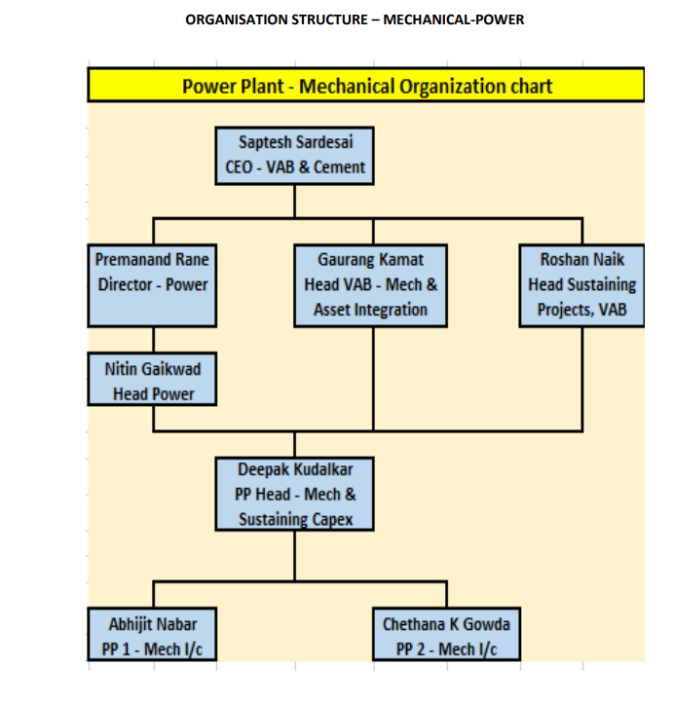

|  |  |  |
| --- | --- | --- |
| **repaired By:**  Head Mechanical | **Reviewed & Issued By:**  Management Representative | **Approved By:**  Head - Power |
| **Signature:** | **Signature:** | **Signature:** |
| **Review Date: 15.08.2023** | **Review Date: 15.08.2023** | **Review Date: 15.08.2023** |